County Information: CAPE MAY COUNTY
Population: 95,634
Broadband Availability | Households with wireline broadband access (Cable, DSL, and Fiber technologies)
*Data found in BEAD 5 Year Action Plan located at: NJ.Gov/Connect/Grants/Overview | Data from American Communities Survey 2022
Office of Broadband Connectivity

The mission of New Jersey’s Office of Broadband Connectivity (OBC) is to ensure that our residents, businesses, and communities have equitable access to affordable Internet service. Internet connectivity provides high-speed internet necessary for economic growth and innovation, education, emergency services, healthcare, and telecommunications infrastructure. Access to high-speed internet helps to ensure public safety, increase opportunities for our businesses and workforce and provide equal opportunity for students.
Asset Inventory
OBC created a website to gather public input on assets that could be recorded in the state inventory. OBC also launched the Digital Equity working group in December 2022, which also supported the buildout of the asset map. (More information on the contributions of the working group are in Section 4.1 of the Digital Equity Plan.) The Asset Map is an ever-evolving data source that captures known assets (CAI’s Education, & Services).
Below are the number of assets identified in Cape May County:
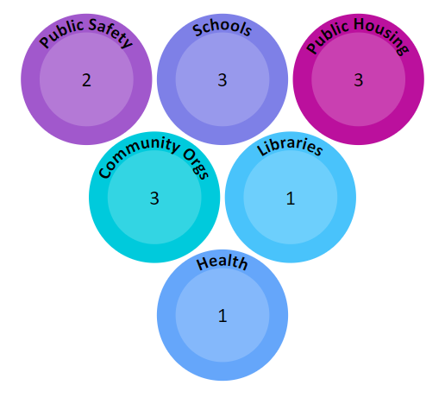 |  | 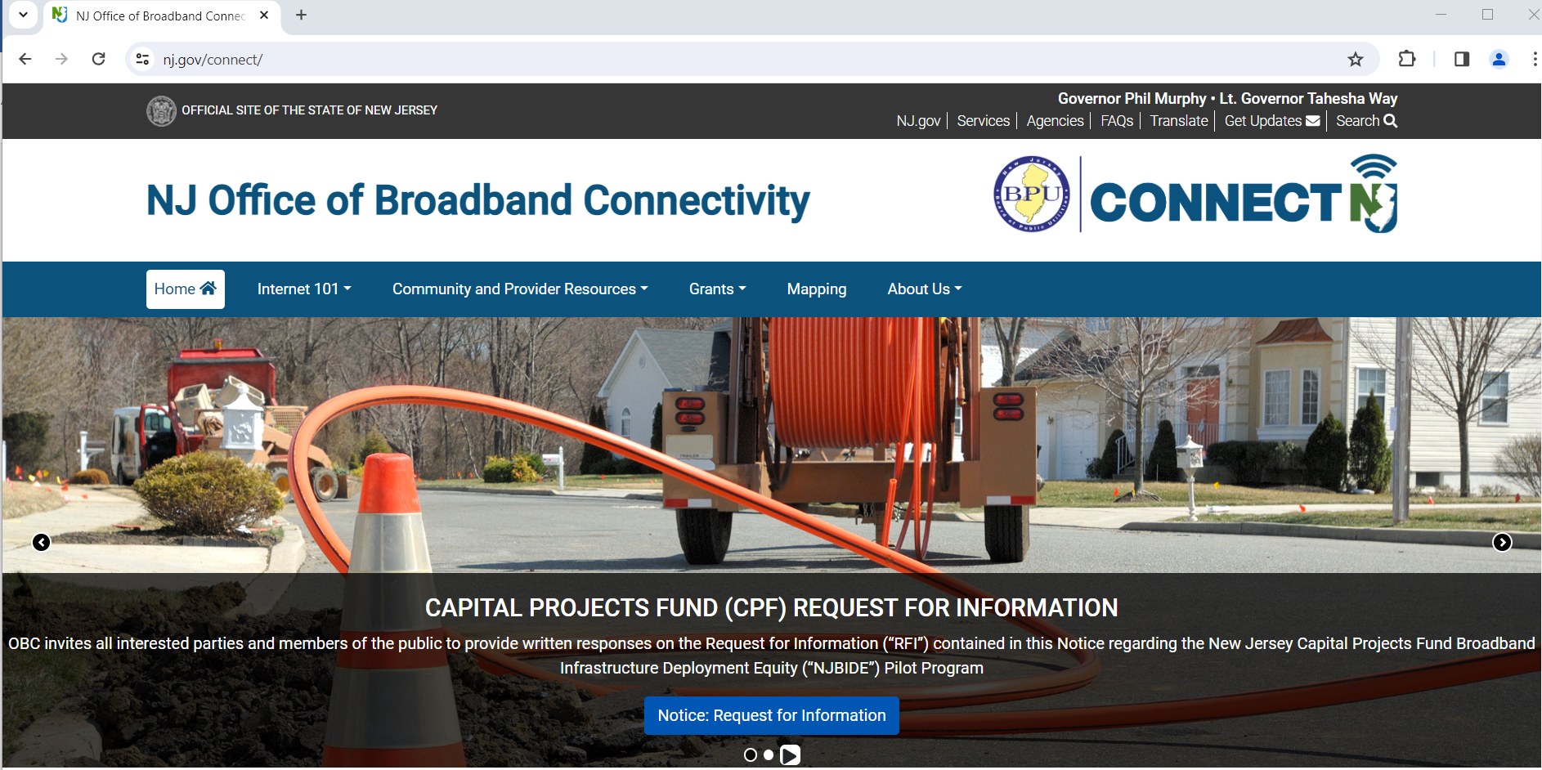
 |  | Help us identify the State’s existing resources, networks, and strengths that address all aspects of the digital divide. Visit: https://www.nj.gov/connect/internet-survey/
Federal Grants:
The Broadband Equity, Access, and Deployment (BEAD) Program  • Allocates $42.45B focused on broadband infrastructure deployment to all states  • New Jersey is expected to receive an estimated $1B+ on top of other funding sources  • States must prioritize funds for:  1. Unserved service projects  2. Underserved service projects  3. Connecting community anchor institutions  4. Installing Wi-Fi infrastructure within residential buildings  5. Data collection  6. Broadband adoption  • States must coordinate with local stakeholders in the planning process  • States must extend access to ALL unserved location |  |  |  | 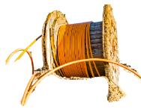
Timeline of BEAD Program
Quarter 2 2024:
- Challenge Process
Quarter 1 2025:
- Award Provisional Grants
- Submit Final Proposal
Quarter 3 2025:
- Begin BEAD Construction
The Digital Equity Programs  Provides $2.75B for digital literacy, computer access, and internet adoption initiatives via  formula-based and competitive grants to states  • Example use of funds:  – Develop, implement, and oversee comprehensive digital equity plans  – Make awards to other entities to help in developing digital equity plans  – Improve the online accessibility and inclusivity of public resources  – Implement digital equity plans and digital inclusion activities  – Provide digital literacy and skills education to covered populations |  |  | “covered populations” in defined as:  1.Individuals who live in covered households  2.Aging individuals  3. Incarcerated individuals, other than individuals who are incarcerated in federal correctional facility.  4.Veterans  5. Individuals with disabilities.  6. Individuals with a language barrier, including individuals who— a. Are English learners, and b. Have low levels of literacy.  7.Individuals who are members of racial or ethnic minority group; and  8. Individuals who primarily reside in aural area.
Timeline of DE Programs:
Quarter 3 2024:
- State Digital Equity Capacity Grant Application
Quarter 1 2025:
Award DE Grants
Capital Projects Fund
The New Jersey Broadband Infrastructure Deployment Equity (NJBIDE) pilot program is a competitive grant program designed to connect areas with limited or no access to reliable broadband internet.
- The program is designed to provide internet service with speeds of 100/100 Mbps upon project completion.
Estimates show that investments made using the Capital Projects Fund will serve ~2.5% of locations still lacking high-speed internet access in the state.
Capital Projects Fund Timeline
Quarter 2 into Quarter 3: Begin Phase two of NJBIDE

